IMPORTING CHARACTER FROM MIXAMO

Upload your character to Mixamo.

- Open your web browser and search for Adobe Mixamo. The first one pops up with the link www.mixamo.com should be the one we need to go to. Please try to find the most relevant one.

- Open the website, log in if you have an adobe account, sign up for free if you don't.

- After logging in, go to the upper right corner of the page and click on Upload Character.

- In the pop-up UPLOAD A CHARACTER window, click on Select character file. Locate and open your model. It may take a while for the character to upload; once the uploading is finished, you should see the character appear in the window.

- Press Next, and follow the instructions to place the landmarks of the body to our character. Press next, wait for it to finish rigging, and next again to finish the setup

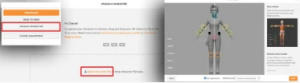

Search and preview animations.

- Click on the Animations tab at the top left corner of the webpage.

- Search for pistol in the search bar.

- In the search result, find and click on the one named the Pistol Walk. Our character in the viewport on the right should already be previewing it.

- We don't want the character to move forward in this case. Check on the In Place check box to lock it at the origin

So why do we want the character to be fixed in place?
Well, the motion of the character should be taken care of by the game programming and not driven by the Animation. You don't want the Animation to tell you how fast your character should be moving.

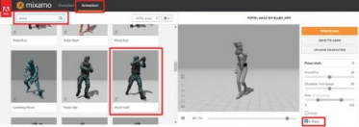

Download animations.

- Press the orange download button. In the pop-up DOWNLOAD SETTINGS, set the Frames per Second to 60.

- Press the DOWNLOAD button to download the Animation.

- Go ahead and download the:
  - Shooting
  - Pistol Idle, and
  - Death From The Back
the same way.

- Create a new folder called MixamoAnimations in the assets folder and put all four downloaded animations there

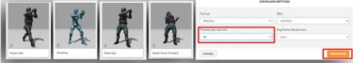
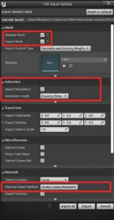
Import the skeletal mesh.

- Go back to our Unreal project.

- Create a folder named Mixamo under the Animations folder.

- Import the downloaded Pistol Walk with the settings shown:

Import the rest of the mixamo animations.

- Import the rest of the animations, but this time, check off Import Mesh

- If the import fails, click the “Import Only Animations” box

Animation Retargeting

Set up a Rig
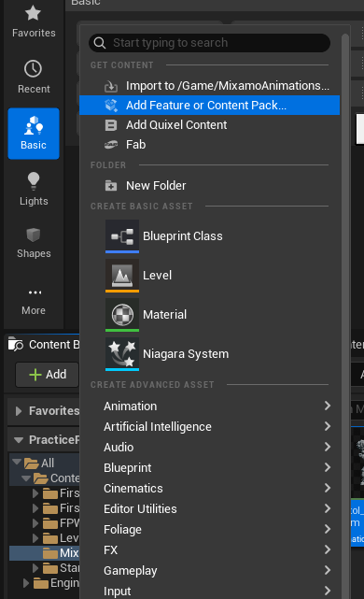
- Import the standard Third Person skeleton by pressing Add in the top-left of Content Browser, and selecting “Add Feature or Content Pack”.

- Select the Third Person content and add it

- Right-click on the animation you want to retarget and select Retarget Animations

- Change the Target Skeletal Mesh to SKM_Manny_Simple

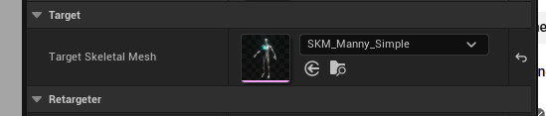

- Click Export Animations, save it to the MixamoAnimations folder, and keep the default settings for the window that pops up

Importing A New Character to Your Mixamo Skeleton

Download your new character

- Go to Mixamo and download another character

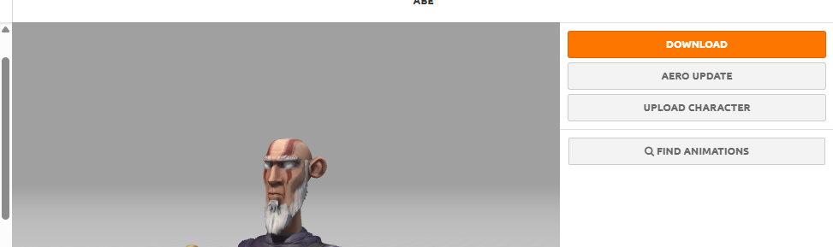

- Drag the new character into your project

- In the Import Settings, uncheck “Import Only Animations” and select your current Mixamo skeleton. I renamed mine to SK_Player

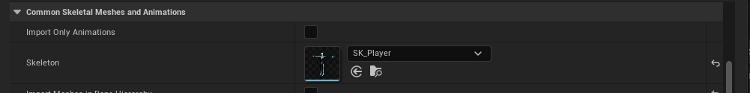

- Make sure “Import Skeleton Mesh” and “Import Materials” and “Import Textures” are checked

- If your character is imported with incorrect or strange materials, open the material by double-clicking it

- In the Event Graph, click on these blue nodes with the images

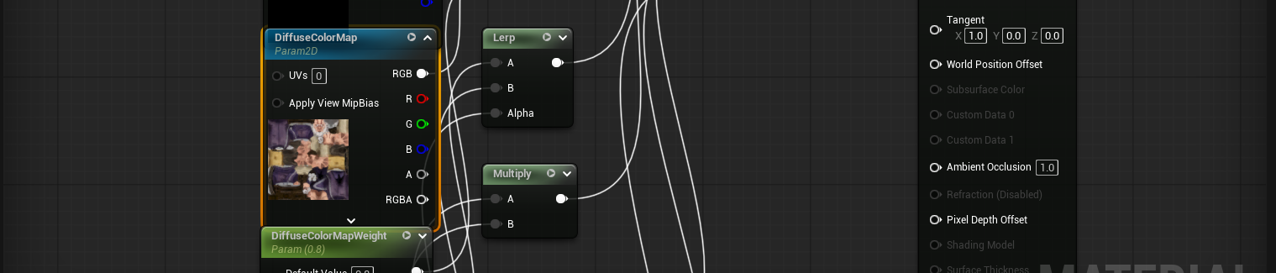

- Then, in the Details panel, find the corresponding texture and set it to the correct one. For example, the Diffuse Color Map should get the texture that’s labeled with “diffuse”

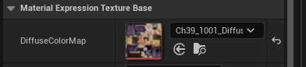

- Test it out by opening your new character’s Skeletal Mesh and pressing “Preview Animation” in the top-left toolbar

